AUTOMATED ESSAY GRADING
Natural Language Processing Project

Submitted By:

Varnika Srivastava 01FB15ECS336
Varun Kumar S 01FB15ECS338
Varuni Sutrave 01FB15ECS343

What is Automated Essay Grading ?

It is an application of natural language processing with an objective is to classify a large set of textual entities into a small number of discrete categories, corresponding to the possible grades—for example, the numbers 1 to 6. Therefore, it can be considered a problem of statistical classification.

The basic procedure for AES is as follows:
1. Start with a training set of essays that have been carefully hand-scored.
2. Evaluate surface features of the text of each essay, such as the total number of words, the number of subordinate clauses, or the ratio of uppercase to lowercase letters—quantities that can be measured without any human insight.
3. Construct a mathematical model that relates these quantities to the scores that the essays received. The same model is then applied to calculate scores of new essays.

Dataset Description

The Hewlett Foundation: Automated Essay Scoring
https://www.kaggle.com/c/asap-aes/data

The dataset has eight essay sets.
Average length of essays : 150 to 550 words per response.
Some of the essays are dependent upon source information and others are not.
All responses were written by students ranging in grade levels from Grade 7 to Grade 10. All essays were hand graded and were double-scored. Each of the eight data sets has its own unique characteristics.
The training dtata file contains 28 columns, they are :
- essay_id: A unique identifier for each individual student essay
- essay_set: 1-8, an id for each set of essays
- essay: The ascii text of a student's response
- rater1_domain1: Rater 1's domain 1 score; all essays have this
- rater2_domain1: Rater 2's domain 1 score; all essays have this
- rater3_domain1: Rater 3's domain 1 score; only some essays in set 8 have this.
- domain1_score: Resolved score between the raters; all essays have this
- rater1_domain2: Rater 1's domain 2 score; only essays in set 2 have this
- rater2_domain2: Rater 2's domain 2 score; only essays in set 2 have this
- domain2_score: Resolved score between the raters; only essays in set 2 have this
- rater1_trait1 score - rater3_trait6 score: trait scores for sets 7-8

The validation and test files each have 6 columns:
- essay_id: A unique identifier for each individual student essay
- essay_set: 1-8, an id for each set of essays
- essay: The ascii text of a student's response
- domain1_predictionid: A unique prediction_id that corresponds to the predicted_score on the essay for domain 1; all essays have this
- domain2_predictionid: A unique prediction_id that corresponds to the predicted_score on the essay for domain 2; only essays in set 2 have this

Approach used to Solve the Problem
LSTM – Long Short-Term Memory
Long short-term memory(LSTM) units (or blocks) are a building unit for layers of abrecurrent neural network (RNN).
A RNN composed of LSTM units is often called an LSTM network. A common LSTM unit is composed of a cell, an input gate, an output gate and a forget gate.
The cell is responsible for "remembering" values over arbitrary time intervals; hence the word "memory" in LSTM. Each of the three gatescan be thought of as a "conventional" artificial neuron, as in a multi-layer (or feedforward) neural network: that is, they compute anactivationusing anactivation function) of a weighted sum. Intuitively, they can be thought asregulators of the flow of values that goes through the connections of the LSTM; hence the denotation "gate". There are connections between these gates and the cell.

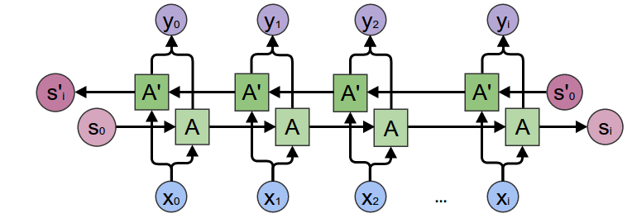

Packages used:
- Numpy
- Pandas
- Tensorflow
- Keras
- NLTK

Architecture of the model built:

Layer Output Shape Param#
-----------------------------------------------------------------
Embedding (None,500, 50) 1837650
LSTM (None,300) 421200
dropout (None,300) 0
dense (None,1) 301
------------------------------------------------------------------

Total params: 2,259,151
Trainable params: 421,501
Non- Trainable params: 1,837,650

Evaluation Metric for the model generated
Kappa and quadratic weighted kappa (QWK) measure the agreement between two raters over the agreement expected by chance. Generally, kappa and QWK range between 0 (no agreement) to 1 (perfect agreement), although smaller and larger values are technically possible. The difference between kappa and QWK is that kappa penalizes all disagreements equally, whereas QWK penalizes larger differences more; in fact, the penalty is the square of the difference.

QWK Scores for the trained model:
Set 1: 0.36
Set 2: 0.50
Set 3: 0.45
Set 4: 0.44
Set 5: 0.66
Set 6: 0.50
Set 7: 0.60
Set 8: 0.33
Weighted QWK score: 0.49
Model trained.

References
https://nlp.stanford.edu/projects/glove/
https://en.wikipedia.org/wiki/Long_short-term_memory
https://www.kaggle.com/c/asap-aes/data
https://deeplearning4j.org/lstm.html

